Super VIP package for the BACC Saturday November 21, Holiday Con. The first 50 VIPs only will get:
1) A James Bond, Man With The Golden Gun Amc Hornet Hatchback (model) (no not the real car)
2) Original 1979 Joe Simon and Jack Kirby Action Bullseye Porfolio, 5 prints
3) High grade copy of Sept 1977, Human Fly no. 1
4) High grade copy of 1986, Pre-Teen Dirty-Gene Kung-Fu Kangaroos #1
5) Maybe best of all it will all come in a super THE AGE OF MARVELS BOX
6) One autograph, and a 11X17 print from our guest Sozomaika
7) One half hour consultation with Comic Maven Mike Carbonaro about collecting, grading, buying and selling comics.
8) Also discounts, and some surprises
Of course, everything will be safe and easy to schlep around, in a heavy duty cotton carry bag, courtesy of our friends and sponsor Landry Pop.
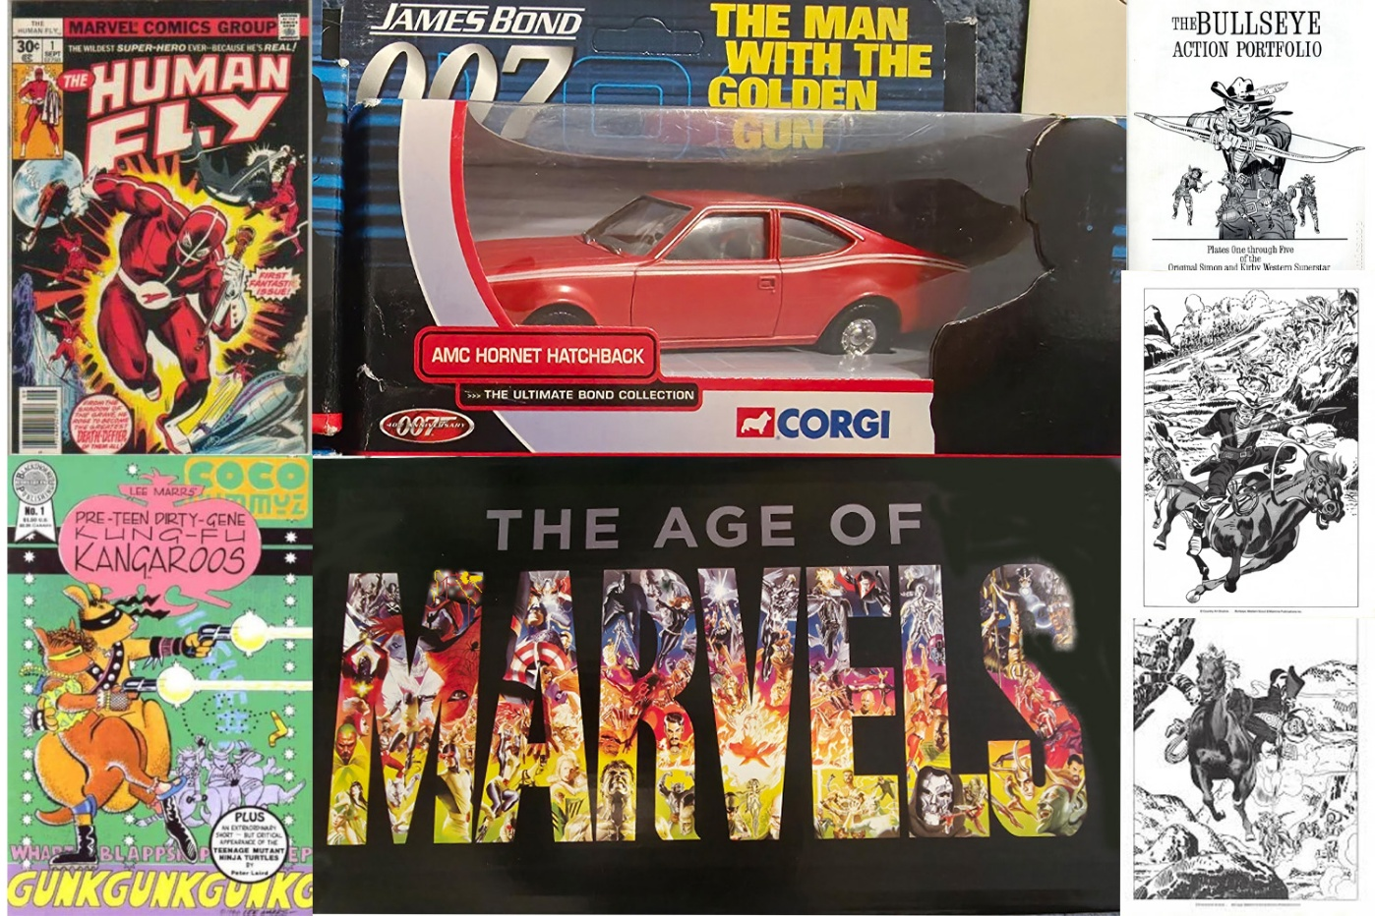
This is a really great VIP pack because we love our fans. But hurry we just have 50 of them (maybe 55), first come first serve. AND we are putting together another bag for the next fifty.

