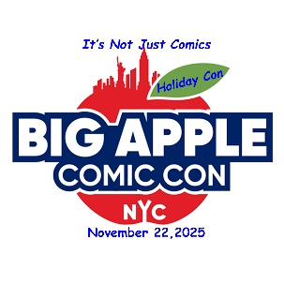
Show Date: SATURDAY NOVEMBER 22, 2025,
Venue: THE NEW YORKER HOTEL, 481 8TH AVE @ 34TH ST.
Big Apple Comic Convention, NYC’s original comic con now in our 29th year, is proud to announce our 5th Annual Holiday Con, a party convention with loads of gifts, prizes, and special events to open and celebrate the Holiday Season, and NYC’s all season love affair with the world of comics and pop culture collectibles with our fans.
The BACC Holiday Con features over 100 exhibitors, artists, guests, and cosplayers, with a special focus on dozens of talented up and coming artists from the NYC area.
All this plus an all-star guest line up including:
- Legendary Marvel Comics Artist/Writer Lawrence Lieber, co-creator of Thor, Iron Man, Ant-Man, and Groot will present his new novel Chirps
- The master of surreal imagery Jim Steranko has transformed comic book visual art.
- Eisner Award winner Dave Dorman, voted the greatest Star Wars artist of all time.
- The independent animation king Bill Plympton (Cannes Festival winner, 2X Oscar nominated, Best Film and Best Director LA animation festival 2023). He’s done dozens of Simpsons Couch Gags too
- Eisner Award winner, visionary artist Alitha Martinez (World of Wakanda, X-Men, Moon Girl, Black Panther).
- The founder and publisher of Coffin Comics Brian Pulido (Lady Death, Hellwitch)
- The political and existential cartoon genius, and master of Spy vs Spy, Peter Kuper (his new book Wish We Weren’t Here)
- Underground Comics legend Larry Welz (Cherry Poptart, Captain Guts)
- Amy Chu, Alpha Girl Comics creator/author, and Bram Stoker Award winner whose unique mindboggling talent includes Red Sonja, Poison Ivy, Carmilla: The First Vampire
- Creees Lee Marvel Bullpen’s hottest young artist (Venom War, Doom’s Division, Iron Man)
- Sean Chen mindbending creator of EVERMIND and innovative artist for Marvel and DC (Wolverine, Electra, X-Men)
- Bill Tucci Inkpot and Eisner Award winner, creator of the phenomenal saga Shi (also Sgt Rock. A Child is Born)
- Nik Virella, the innovative and spectacular art sensation (Wolverine, Hyperion, 1872)
- Ryan Dunlavey highly awarded artist/author is the philosopher and historian is the conscience of comics alternately hilarious and profound (Action Philosophers, Modok Reign Delay, My Bullshit)
- Mr Archie Comics himself Harvey and Glad Award winner Dan Parent. Admit it, everyone loves Archie.
- Kristen Gudsnuk writer/artist of the groundbreaking Henchgirl and the hit series Making Friends
- Author, and Marvel Comics editor Danny Fingerorth (Biogrpahies of Stan Lee, and Superman)
- Topps sport cards master illustrator Brian Kong (Walking Dead, Star Wars, MLB, NFL)
- The one and only Star Wars GREDO character Paul Blake 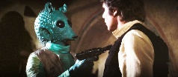
- The “Funny Bunny” Julie McCullough (Golden Girls, Drew Carey Show, Growning Pains)
AND
- Very Special Guest with Crash Media Partners, Al Kahn the man who brought the multi-billion-dollar Pokemon and Yu-Gi-Oh! Japanese anime franchises to the world outside of Japan
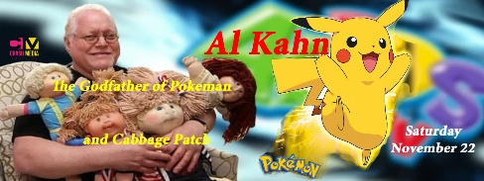

STOP THE PRESSES we are presenting the illusive mythical irreverent indie comics god R.Crumb’s first published work in 23 years, Tales of Paranoia hot off the press (all VIP tickets get a free one).
Of course our famous NYC Cosplay Contest (are you ready for some real kitch?).
This will be our best show ever, as usual in the fabulous Art Deco masterpiece New Yorker Hotel (481 8th Ave @34th St). Maybe Santa will show early this year.
The BACC is a collectible dreamworld event, a national hub for collectors and traders, with some of the greatest collectible books are exhibited, and traded.
Big Apple Comic Con “Holiday Con,” Saturday, November 22, 2025 10am-7pm (early admission 9am)
Tickets: General Admission $30; VIP Admission $85; Kids under 14 $15, Kids under 10 are Free.
For information, and booking, contact press@bigapplecc.com

