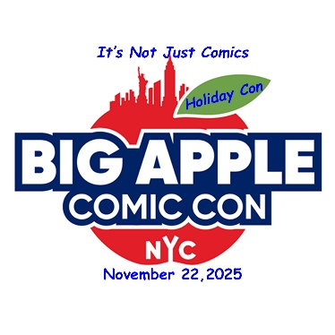
NOVEMBER 22, 2025
Big Apple Comic Con Holiday Con
VIP PACKAGE
- One Copy of Tales of Paranoia, R. Crumb’s 1st published work in 23 years.
- Complete set of the 6 original 1983, Frank Miller, Ronin books,
- Second Wednesday book by J.C. Vaughn (he will sign them at the show),
- Chirps Novel by the legendary Lawrence Lieber (Yes Stan's Bro, he will sign them at the show),
- The Bullseye Action Portfolio - A portfolio of five lithograph prints by comic legends Joe Simon and Jack Kirby, featuring their Western hero Bullseye.
- ½ hour consultation with Micheal Carbonaro, evaluate your collection, grading, collecting, anything to do with collectibles, buying and selling
- Plus special offers, early admission and a great tote bag by our partner Landry Pop Auctions
VIP Tickets are $85 The BACC VIP Partner Forever Pass is $575
GET TICKETS HERE

